IT5512- WEB TECHNOLOGY LAB-SESSION-1
DATE: 06/09/2021 FN
NAME: A.S. PRUTHIEV
REG NO.2019506067
BASIC JAVA PROGRAMS
1) AIM:
To write a Basic Java code for the following Programs:
1 a) Write a java program to display Fibonacci series
1 b) Write a java program to check whether a number is Armstrong or not
1 c) Write a java program to check whether a number is palindrome or not.
1 d) Write a program to find a factorial of a number
1 e) Write a program to find sum of all integers greater than 100 and less than 200 that are divisible by 4.
1 f) Write a program to print even numbers between 1 to 20
1 g) Write a program to check whether a number is positive or negative
1 h) Write a program to display the student details.

PROCEDURE:
- Download the Java Development Kit (JDK version 8) from oracle
- Download and install IntelliJ IDEA IDE from JetBrains
- Once JDK is installed add the path variable in the system variable environment setting
- Create a project in IntelliJ and configure the SDK version, enter the project and package name and click on finish. IntelliJ will load and set up the required components
- Create a new file from File → new Class → Enter the name
- Code up the algorithm and run it using the Run button.
- The source code is compiled using JAVAC compiler which comes along JDK and the output is displayed on the terminal.
1) a.
AIM:
To Write a java program to display Fibonacci series

PROGRAM CODE:
package Java.Lab.lab1;

import java.util.Scanner;

public class FiboNacci {
private static Scanner input = new Scanner(System.in);
public static void main(String[] args) {
int n;
System.out.print("Enter the number of Fibonacci Series to be generated :");
n = input.nextInt();
int []fibo = new int[n+1];
fibo[0] = 0;
fibo[1] = 1;
for(int i = 2 ; i <= n ; i++){
fibo[i] = fibo[i-1] + fibo[i-2];
}
System.out.print("The fibonacci series are :");
for(int i = 0 ; i < fibo.length ; i++){
System.out.print(fibo[i] + " ");
}
}
}

OUTPUT:

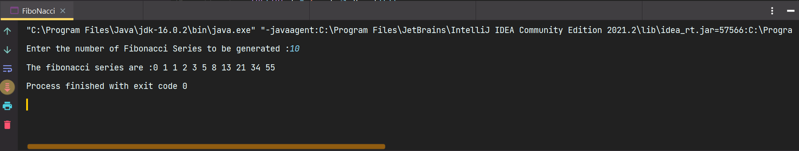

RESULT:
Thus, the program has been executed successfully.
1) b.
AIM:
To Write a java program to check whether a number is Armstrong or not

PROGRAM CODE
package Java.Lab.lab1;

import java.util.Scanner;

public class ArmstrongNumber {
private static Scanner input = new Scanner(System.in);
public static int numberOfDigits(int num){
int ans = 0;
while(num != 0){
ans ++;
num /= 10;
}
return ans;
}
public static void main(String[] args) {
int n;
System.out.print("Enter a number :");
n = input.nextInt();
int numberOfDigits = numberOfDigits(n);
int ans = 0;
int m = n;
while(m != 0){
ans += (int)Math.pow(m % 10,numberOfDigits);
m /= 10;
}
if(ans == n)System.out.print("The number " + n + " is an armstrong number ");
else System.out.print("The number " + n + " is not an armstrong number ");
}
}

OUTPUT:

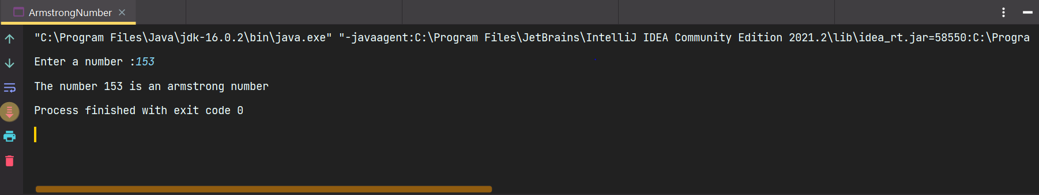

RESULT:
Thus, the program has been executed successfully.

1 ) c.
AIM:
To Write a java program to check whether a number is palindrome or not

PROGRAM CODE:

package Java.Lab.lab1;

import java.util.Scanner;

public class PalindromeNumber {
private static Scanner input = new Scanner(System.in);
public static void main(String[] args) {
int n;
System.out.print("Enter a number :");
n = input.nextInt();
int m = n;
int ans = 0;
while(n != 0){
ans = ans * 10 + n % 10;
n /= 10;
}
if(ans == m)System.out.print("The number " + m + " is a palindrome number ");
else System.out.print("The number " + m + " is not a palindrome number ");

}
}

OUTPUT:

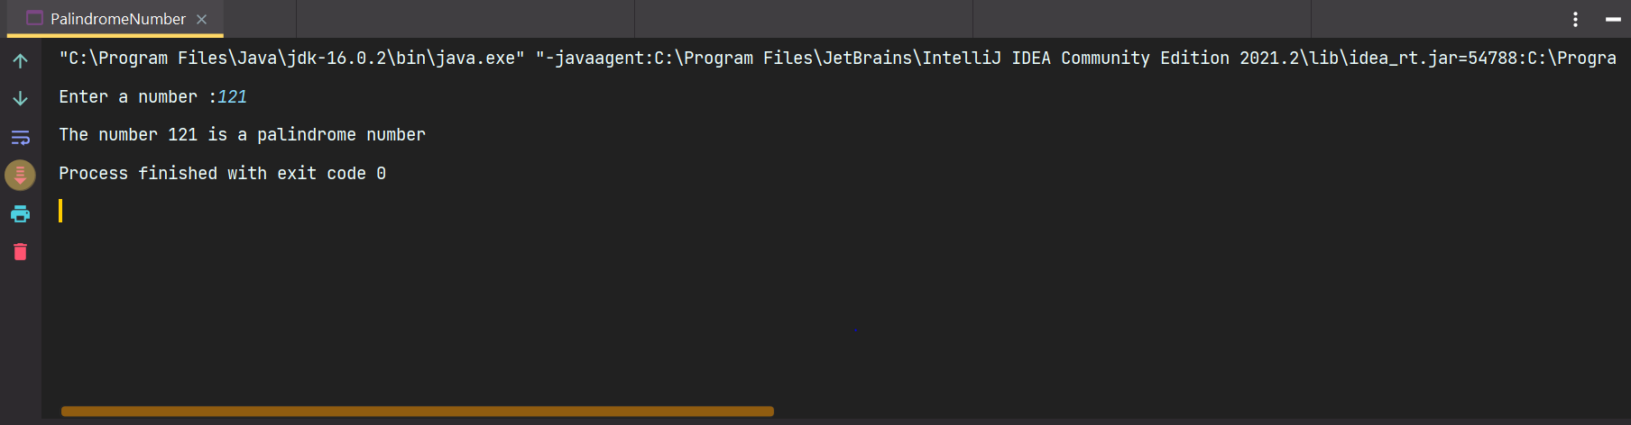

RESULT:
Thus, the program has been executed successfully.
1) d.
AIM:
To Write a java program to find a factorial of a number.

PROGRAM CODE:

package Java.Lab.lab1;

import java.util.Scanner;

public class Factorial {
private static Scanner input = new Scanner(System.in);
public static long getFactorial(int num){
long ans = 1;
for(int i =2 ; i <= num ; i++){
ans *= i;
}
return ans;
}
public static void main(String[] args) {
int n;
System.out.print("Enter a number :");
n = input.nextInt();
System.out.print("The factorial of the numnber " + n +" is :" + getFactorial(n));
}
}

OUTPUT:

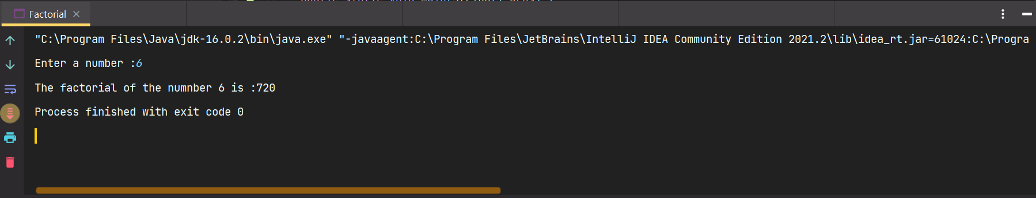

RESULT:
Thus, the program has been executed successfully.
1) e.
AIM:
To write a program to find sum of all integers greater than 100 and less than 200 that are divisible by 4

PROGRAM CODE:

package Java.Lab.lab1;

public class SumNum {
public static void main(String[] args) {
int sum = 0;
for(int i = 100 ; i < 200 ; i++){
if(i % 4 == 0)sum += i;
}
System.out.print("The sum of the numbers >= 100 and < 200 is :" + sum);
}
}

OUTPUT:

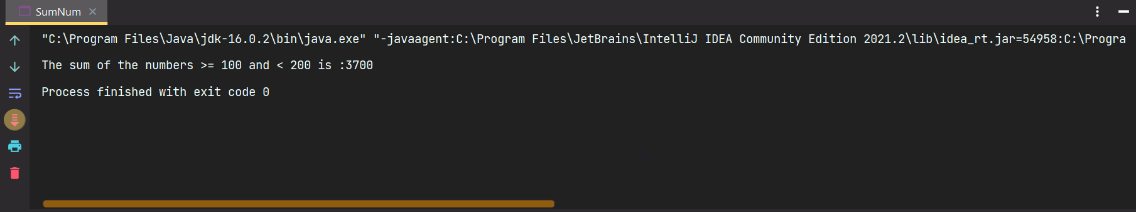

RESULT:
Thus, the program has been executed successfully.
1) f.
AIM:
To Write a program to print even numbers between 1 to 200

PROGRAM CODE:

package Java.Lab.lab1;

public class PrintEven {
public static void main(String[] args) {
System.out.println("The even numbers between 1 and 200 are as follows :");
for(int i = 1 ; i <= 200 ; i++){
if(i % 50 == 0)System.out.println();
if(i % 2 == 0)System.out.print(i + " ");

}
}
}

OUTPUT:

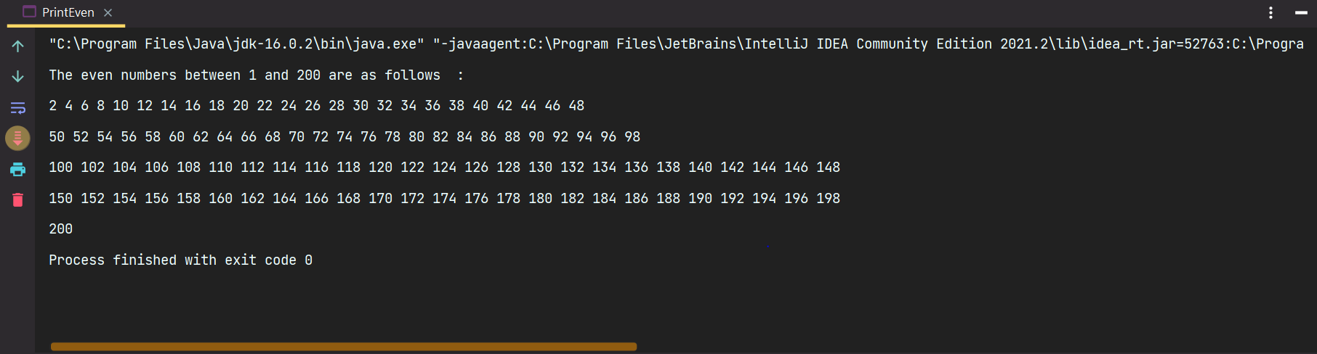

RESULT:
Thus, the program has been executed successfully.
1) g.
AIM:
To Write a program to check whether a number is positive or negative

PROGRAM CODE:

package Java.Lab.lab1;

import java.util.Scanner;

public class PosNegnumber {
private static Scanner input = new Scanner(System.in);
public static void main(String[] args) {
int n;
n = input.nextInt();
if(n >=0 )System.out.print("The number is positive");
else System.out.print("The number is negative");
}
}

OUTPUT:

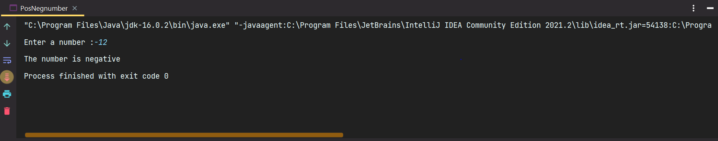

RESULT:
Thus, the program has been executed successfully.

1)h.
AIM:
To Write a program to display the student details.

PROGRAM CODE:

package Java.Lab.lab1;

import java.util.Scanner;

class StudentDetails{
private final static Scanner input = new Scanner(System.in);
private int age;
private String name,phoneNumber,rollNumber;
private int []marks;
private int numberOfSubjects;
private double cgpa;
StudentDetails(int age, String name, String phoneNumber, String rollNumber,int numberOfSubjects ) {
this.age = age;
this.name = name;
this.phoneNumber = phoneNumber;
this.rollNumber = rollNumber;
this.numberOfSubjects = numberOfSubjects;
marks = new int[numberOfSubjects];
System.out.print("Enter subject marks :");
for(int i = 0 ; i < numberOfSubjects ; i++){
marks[i] = input.nextInt();
}
input.nextLine();
}
public int getAge() {
return age;
}
public String getName() {
return name;
}
public String getPhoneNumber() {
return phoneNumber;
}
public String getRollNumber() {
return rollNumber;
}
public double getCgpa() {
return cgpa;
}
void calculateCGPA(){
double total = 0d;
for(int i = 0 ; i < marks.length ; i++)total += marks[i];
cgpa = total / (double)numberOfSubjects;
}
}
public class Student {
private final static Scanner input = new Scanner(System.in);
public static void main(String[] args) {
int n;
int age;
String name,phoneNumber,rollNumber;
int numberOfSubjects;
System.out.print("Enter the number of students :");
n = input.nextInt();;
StudentDetails [] students = new StudentDetails[n];
for(int i = 0 ; i < n ; i++){
input.nextLine();
System.out.print("Enter the name : ");
name = input.nextLine();
System.out.print("Enter the age :");
age = input.nextInt();
input.nextLine();
System.out.print("Enter the phone Number :");
phoneNumber = input.nextLine();
System.out.print("Enter the roll number :");
rollNumber = input.nextLine();
System.out.print("Enter the number of subjects :");
numberOfSubjects = input.nextInt();
students[i]=new StudentDetails(age,name,phoneNumber,rollNumber,numberOfSubjects);
students[i].calculateCGPA();
}
for(int i = 0 ; i < n ; i++){
System.out.println("The name is :" + students[i].getName());
System.out.println("The age is :" + students[i].getAge());
System.out.println("The roll number is :" + students[i].getRollNumber());
System.out.println("The phone number is :" + students[i].getPhoneNumber());
System.out.printf("The CGPA is : %.2f" + students[i].getCgpa());
}
}
}

OUTPUT:
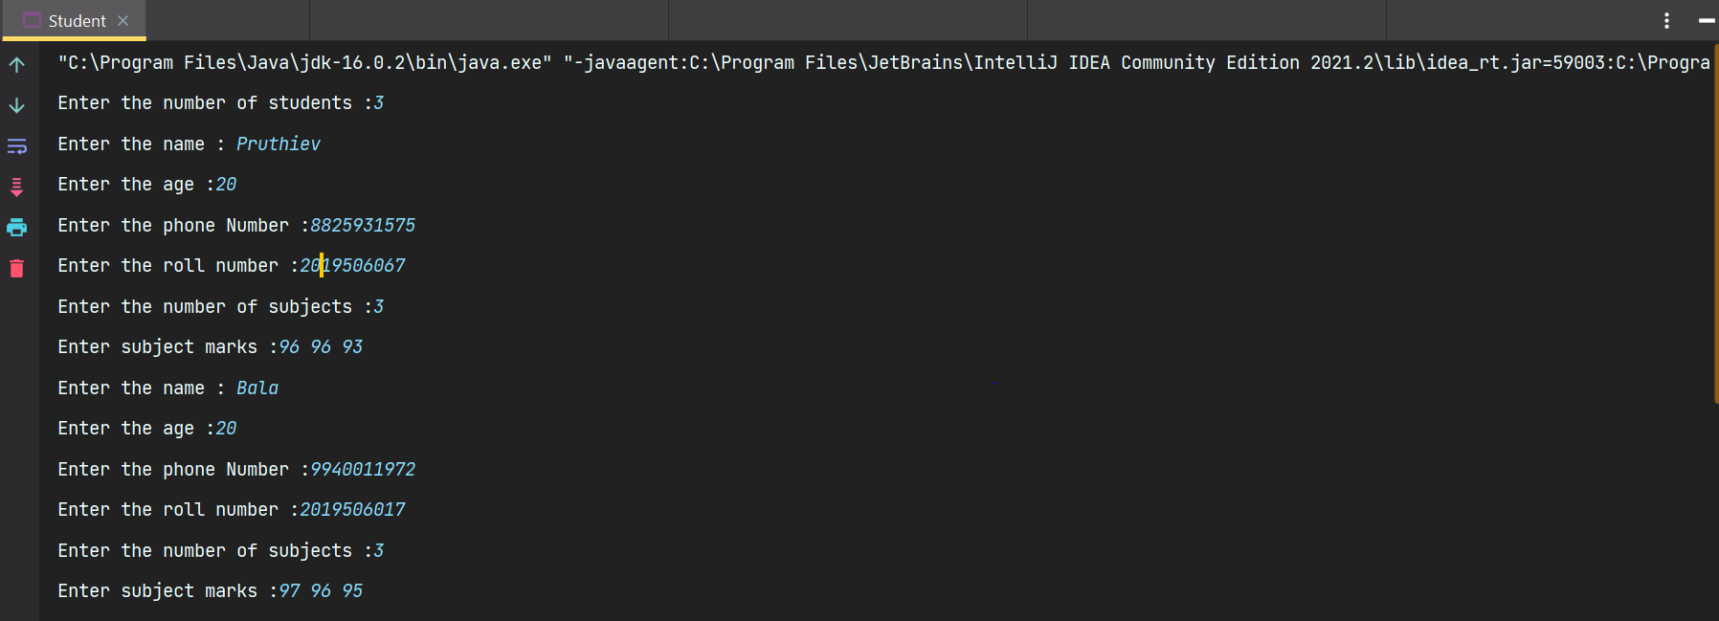

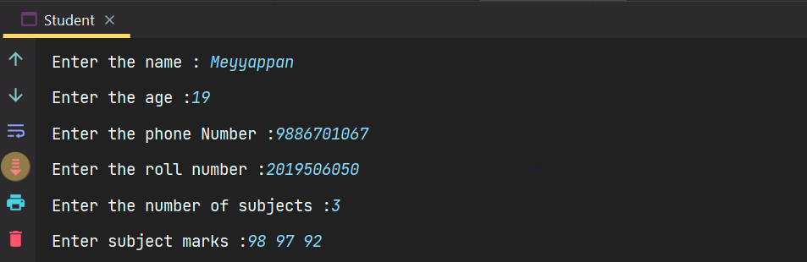

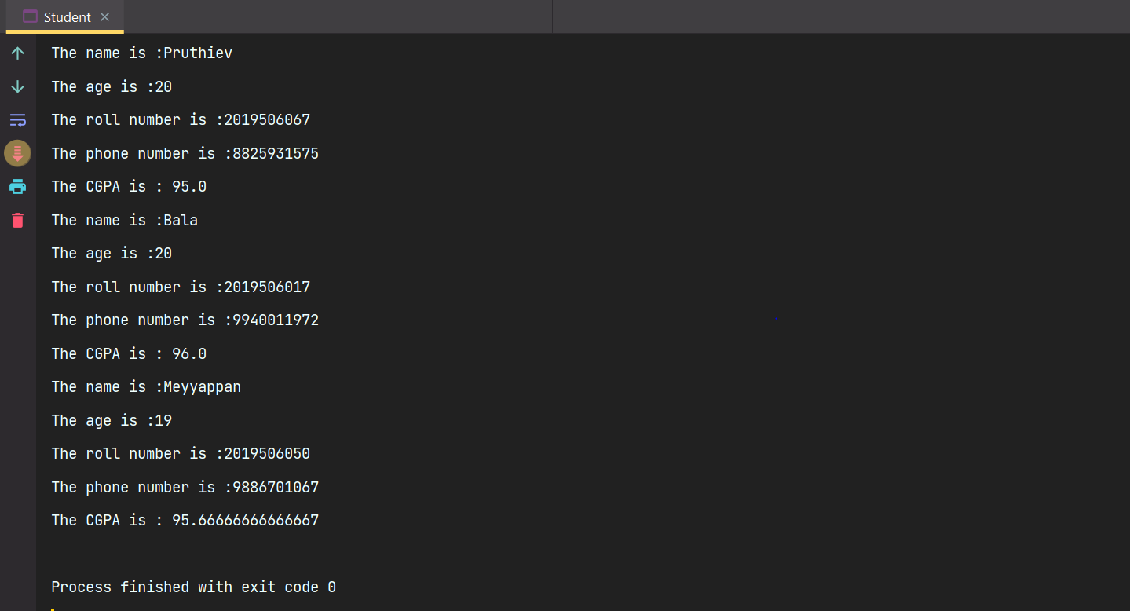

RESULT:
Thus, the program has been executed successfully.

